User Manual

FMS^{NG} Application

Shell Energy Marketing and Trading India Private Limited
Project Sponsoring Business

Exchange Module

19 MAR 2024
Date

Table of Contents
1. Exchange Module Overview 3
1.1. User Interface / Screen Designs 3
2. Menu Network / Screen Navigation 4
2.1. Sub Module – Remittance 4
3. Auditing 12

Exchange Module Overview
FMS^{NG} Application is an efficient ETRM System for Domestic Gas Trading, customized to meet business requirement of Shell Energy Marketing and Trading India Private Limited (SEMTIPL).
FMSNG Gas Exchange Module propose to manage IGX Transaction for Domestic Gas trading as listed below:

• IGX Transaction Remittance
• Interfacing with SAP P80 to flow Financial Information
• System will trigger event based emails as applicable
• Management Reports

User Interface / Screen Designs

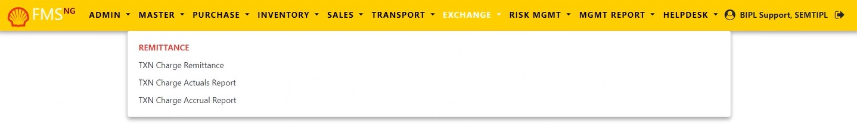
FMS^{NG} offers Responsive UI to enable usability via any smart phone, tab and laptop of any screen size. The Menus of Exchange module are as below:

The responsive mode view over iPhone simulation:
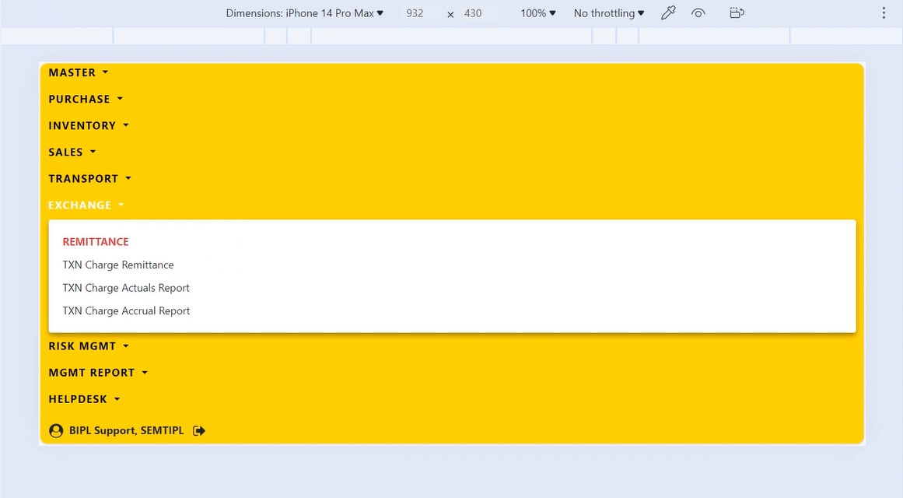

Menu Network / Screen Navigation
Menus in any Module are kept under different Groups for better categorization. The Groups under Exchange Module is Remittance.

Sub Module – Remittance

Remittance – TXN Charge Remittance

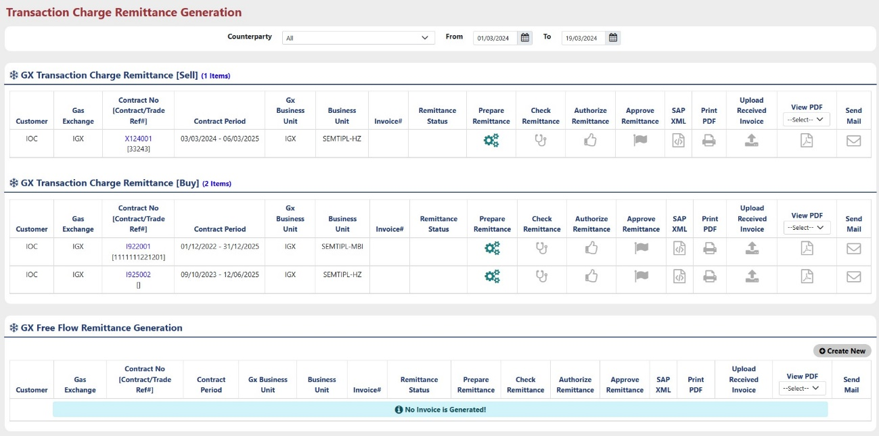
TXN Charge Remittance Preparation is used for generating remittance for Sell and Buy both side. User can create GX free flow Remittance.

User can select “Month/Year” and “Billing Cycle” from the dropdown for which remittance will be generated.

Here User can generate remittance in two ways,
- First, go through all the process as explained in “Purchase” and “Sales” module after Creating Contract and then generate remittance.
- Second, Create Free flow remittance Using “Create New” button in this form without doing any Nomination and allocation process directly after Creating Contract.

Method 1 : Follow below steps to Generate remittance through all the Process:

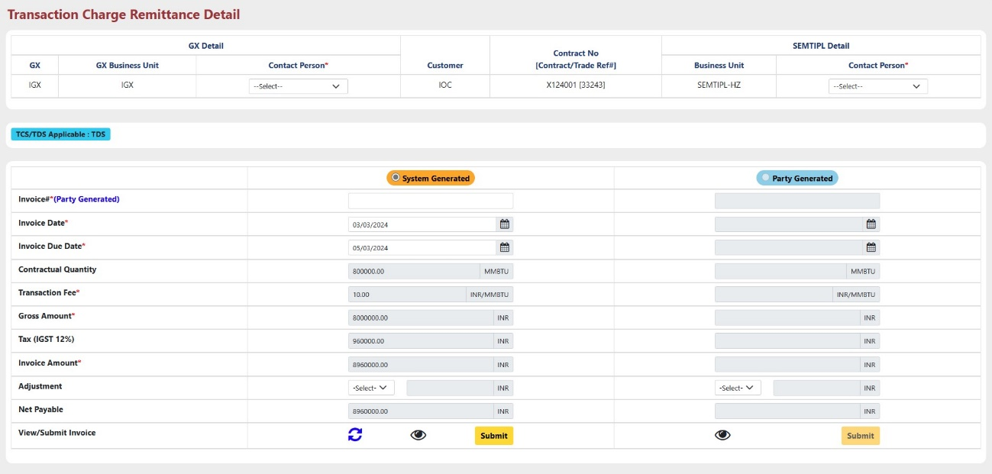

- Click on button to Prepare remittance for which user wants to generate remittance. The popup new screen will open shown as below.

- Select Contract Person from the drop down for both, Business details.
- Here, Two types of Invoice details can be entered, “System Generated” and “Party Generated”.
- In System Generated part all the details will be filled by the system by itself according to the contract details.
- In Party Generated part all the information will be entered by the trader.
Note*: Party Generated part will be enabled only after check remittance part will be completed for System generated Invoice.

- Fill all the required details.
- Use button to reset all the fields.
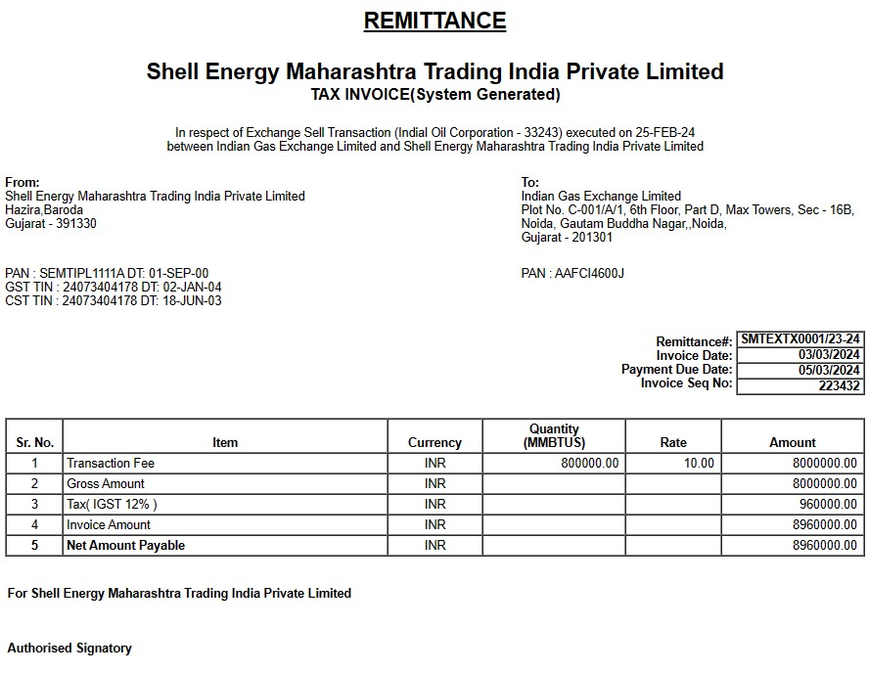

- Use button to view how the invoice will be look like.
- Click on “Submit” button to submit all the details and prepare remittance.

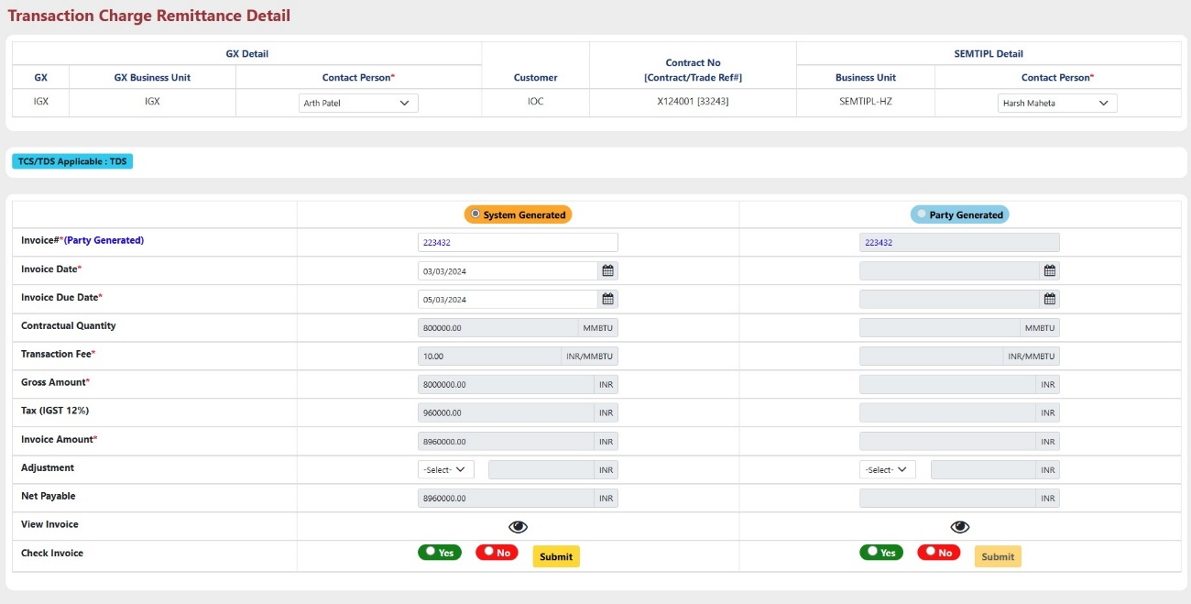


- After that button will be enabled. Use button to check whether all the details entered for remittance is correct or not.

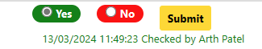
- Select “Yes” or “No” in order to check invoice and Click “Submit” button to submit response.
- After submission, this type of message will appear.

- After that button will be enabled. Use button to Authorize remittance details.
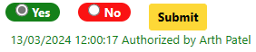
- To authorize Remittance details, Select “Yes” or “No” and then click “Submit” button.
- After submission, this type of message will appear.

- After that button will be enabled. Use button to Approve or Reject remittance details.
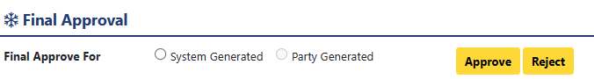

- Select “System Generated” or “Party Generated”, for which type invoice further process will execute. And then click “Approve” or “Reject” button.
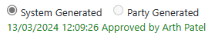

- After Approval, this type of message will appear.
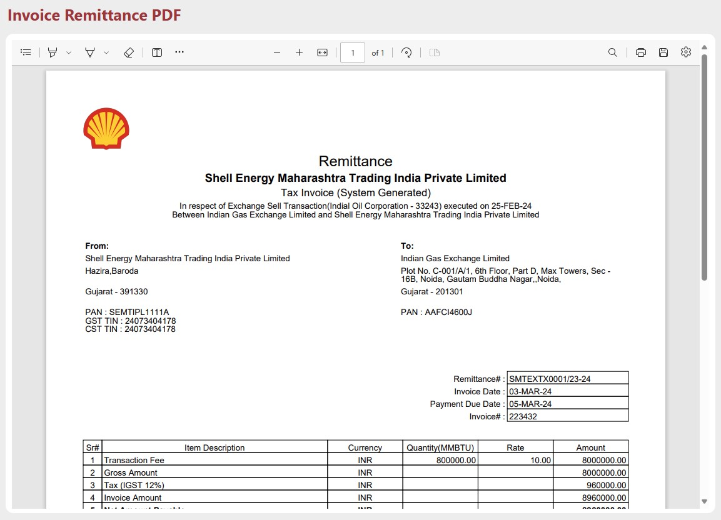

- After that, click on button in order to generate PDF.

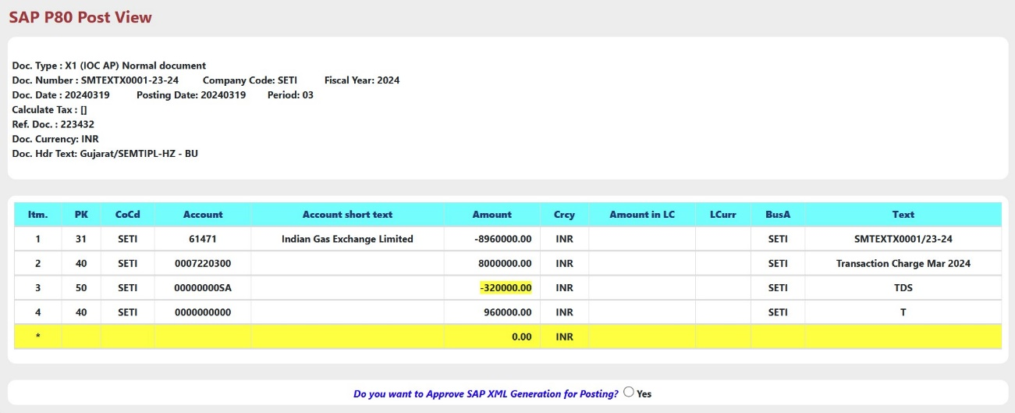
- After that, click on button in order to approve SAP-XML.

- Select “Yes”, to approve SAP XML generation for posting. After successful approval below message will appear.

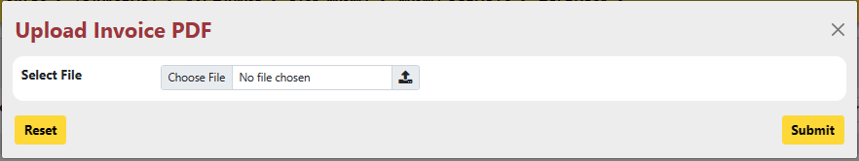

- User can Upload Received Invoice from the party i.e. Party Generated Invoice using button.

- Select PDF file from your system and click “Submit” button.

- After Submission icon will be converted to icon.

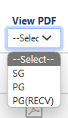
- User can view Invoice in pdf format by selecting type of Invoice from the dropdown.

- Here SG : System Generated
PG : Party Generated
PG(RECV) : Party Generated Received (Uploaded using button.)

- After Selecting any type, if PDF file is available then will be enabled and will be look like .
- User can view PDF using button.

- User can send mail directly from this form using button only after uploading received Invoice.
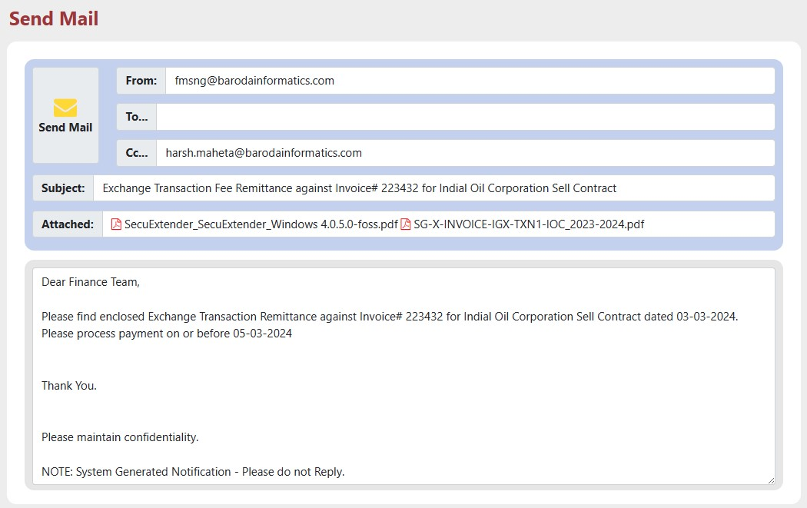
- Click on “Send Mail” Button to send mail.

Method 2 : Follow below steps to Generate Purchase Free Flow Remittance :

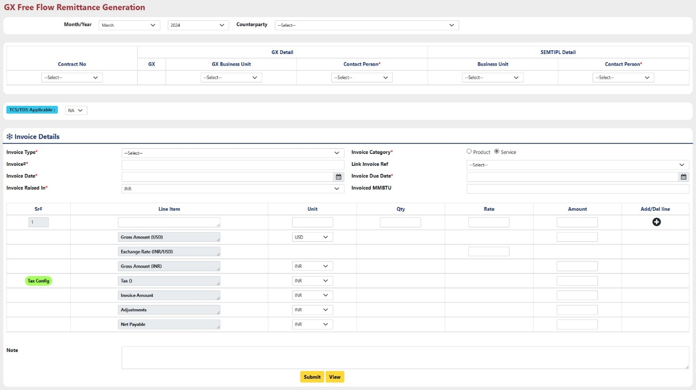
- Click On “Create New” button located at the top right corner of the ‘GX Free Flow Remittance Generation’ Part.

- Month/Year: Select month & year from the dropdown.
- Select Counterparty: Select Counterparty from the dropdown for which Invoice will be generated.
- Contract No. : Select Contract for the selected Counterparty from the existing Contracts.
- GX Business Unit (GX Details): Select Business unit for which invoice will be generated.
- Contact Person (GX Details): Select Contact person for the Selected Business unit.
- Business Unit (owner (SEMTIPL) Details): Select Business Unit from the dropdown.
- Contact Person (owner (SEMTIPL) Details): Select Contact person from the dropdown.
- TCS/TDS Applicable: If “TCS” or “TDS” applicable on the invoice, select from the dropdown, else Select “NA” to proceed further.
- Invoice type: Select Invoice Type from the Dropdown.
- Invoice Category: Select Invoice Category, for which category invoice will be generated.
- Invoice#: Enter invoice number.
- Link Invoice Ref: Link reference with invoice if any available.
- Invoice Date: Enter date on which invoice will be raised.
- Invoice Due Date: Enter due date for invoice.
- Invoice Raised In: Select In which Currency Type Invoice will be raised.
- Invoiced MMBTU: Enter quantity of Gas in MMBTU unit, for how much of quantity Invoice will be generated.
- Line Item: User have to enter Name of Item (Product or Service) for which Invoice will be generated at the first Row of Line Item Column.
- Unit: Enter Unit as “INR” or “USD” as per the item’s amount.
- Qty: Enter quantity of item.
- Rate: Enter Rate of the Item.
- Amount: Enter Price of Item.
- Add/Del Line: User can add more lines in order to add more item.
- Gross Amount (USD): Enter Gross Amount in USD in Amount Column.
- Exchange Rate: Enter your preferred exchange rate from USD to INR.
- Gross Amount (INR): Enter Gross Amount in INR according to exchange rate.
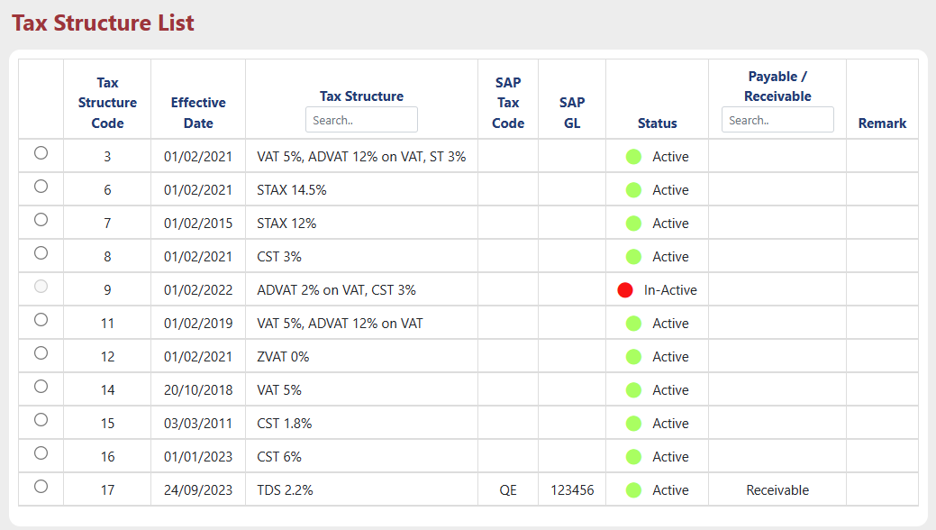
- Tax (): Configure tax details by using “Tax Config” button.
Select preferred tax from the list. Enter Tax amount in amount Column.
- Invoice Amount: Enter Total amount of Invoice in amount column.
- Adjustment: Enter amount of adjustment if applicable.
- Net Payable: Enter the final payable amount after Adjustment will be paid.
- Note: User can add some note for future reference.

Click “Submit” button to submit all the details.
After Successful submission, User can see how invoice view will be like by using “View Button”.

- Further Process for the Remittance Preparation, Check Remittance, Authorize Remittance, Approve Remittance, SAP XML, Print PDF, Upload Invoice and Send Mail is exactly same as step-1.

Remittance – TXN Charge Actual Report

TXN Charge Actual Report will be generated for the Contracts after Invoice were generated.
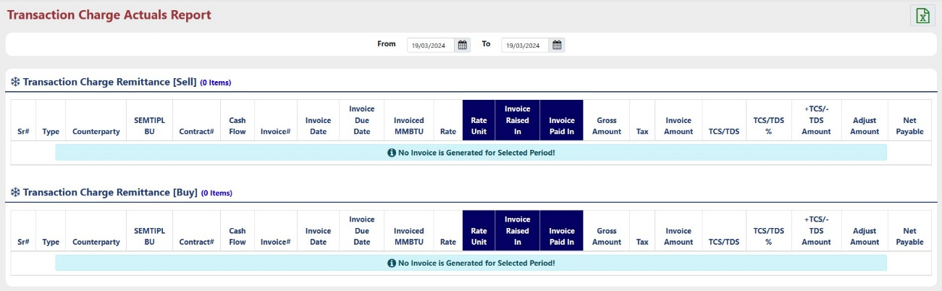
Increase Date Range by changing ‘From’ and ‘To’ date.
TXN Charge Actual Report contains all the information about Contract and Invoice Raised for available contracts.
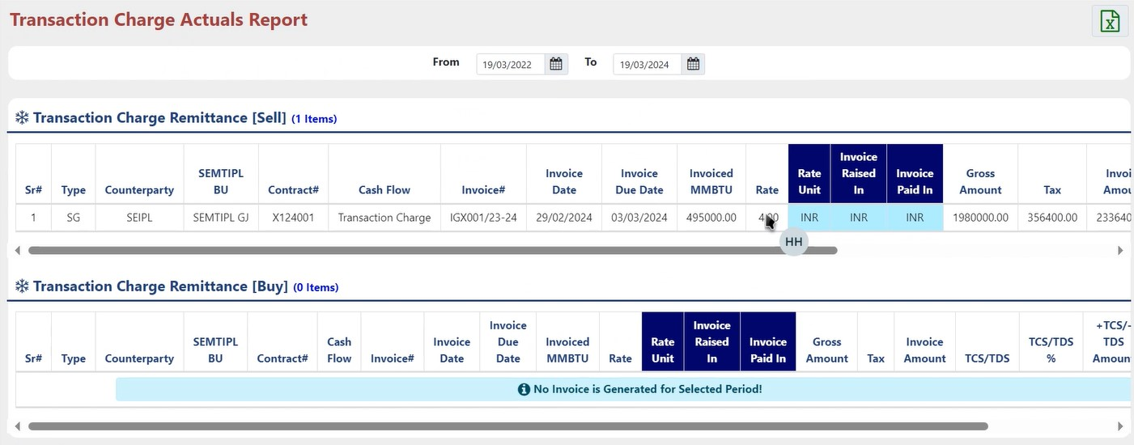

Remittance – TXN Charge Accrual Report

TXN Charge Accrual Report will generated before the Invoice were generated.
This Report contains all the Information about contract and accrual Gas amount.
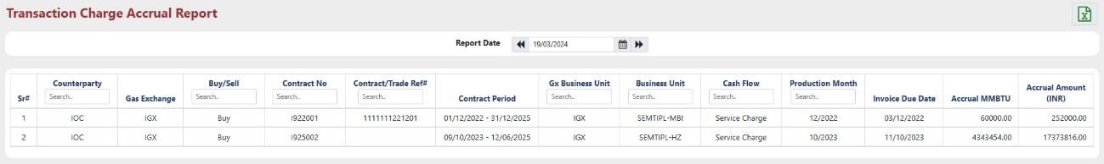

Auditing

The "Audit Trail" within the "Admin" module comprehensively tracks and stores all user actions performed across the various sub-menus of the "Exchange" module, providing a detailed record of changes made to the system's master data.

